Properties of Macromolecules

Introduction

Water is an extremely important compound in the bodies of all living things. We have spent the last two labs examining a variety of different physical and chemical properties of aqueous (water-based) solutions. But the bodies of living things are obviously much more than water. In this lab, we will explore properties of the special carbon-based molecules that make life so complex and diverse. Carbon atoms form four covalent bonds so they are capable of forming long chains. Because each carbon atom only uses two bonds to hold on to each adjacent carbon atom in the chain, it is able to form two more bonds with other atoms or groups of atoms. This allows for some of the long carbon chains to be almost infinitely complex in their structure and function. DNA and proteins, for example, are so varied across life forms, that for all non-clonal individuals, these compounds are essentially unique.

Because these carbon chains form extremely large molecules often consisting of thousands or hundreds of thousands of atoms, we refer to them collectively as macromolecules. You might think of something like water or carbon dioxide that consists of only a few atoms per molecule as a ‘micromolecule’, but that term is not really used. Because macromolecules are so large and so complex, we study them as chains of smaller molecules. Each type of macromolecule is made up of specific subunit molecules. One of those subunit molecules is called a monomer. A large molecule consisting of multiple monomers is called a polymer.
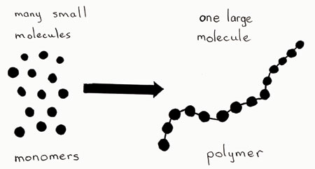

Smaller Molecules

Large Molecule

POLYMER
MONOMERS
linkage

FIGURE 6-1

There are four major categories that we use to classify macromolecules; Carbohydrates, Proteins, Lipids, and Nucleic Acids. The table shown on the next page summarizes the four categories of macromolecule with the name of the monomers that form each, the type of chemical bond or ‘linkage’ that hooks monomers together to form polymers, and some specific examples of compounds that are found in each category.

Category | Monomer | Linkage | Examples
Carbohydrates | monosaccharide | glycosidic | sugars, starches, cellulose
Proteins | amino acid | peptide bond | structural proteins and enzymes
Lipids | fatty acid, glycerol | ester | fats, oils, waxes
Nucleic Acids | nucleotide | phosphodiester | DNA and RNA
TABLE 6-1

Carbohydrates are important energy storage compounds (e.g. sugars, starches, and glycogen) and important structural compounds (e.g. cellulose in plant cell walls and chitin in arthropod exoskeletons). They are composed of carbon, hydrogen and oxygen – carbon containing compounds that are hydrated (contain water). Most of the carbon atoms in a carbohydrate are linked to a hydrogen atom and a hydroxyl (OH) group. The simplest sugars are called monosaccharides. They typically have five or six carbons arranged in a ring. An important five carbon sugar (pentose) is the deoxyribose sugar that is part of the nucleotides that make up DNA molecules. Examples of six carbon sugars (hexoses) are glucose and fructose shown below. You will notice that two monosaccharides can be combined in a dehydration reaction that results in a glycosidic bond between them. This produces a disaccharide – in this example, glucose and fructose combine to make sucrose, the sugar that you add to coffee or tea. When many monosaccharides are linked together to form long polymers they are called polysaccharides. Here starch is given as an example of a polysaccharide. It is composed of many glucose monomers linked together by glycosidic bonds.

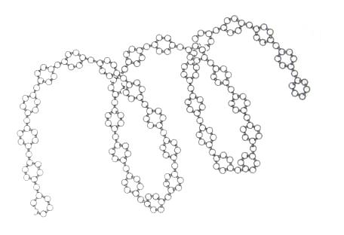
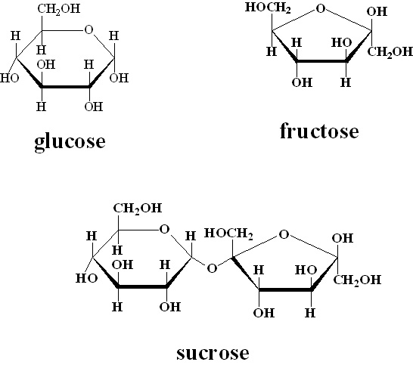
(monosaccharide)
(monosaccharide)
one glucose molecule

Starch
(polysaccharide)

(disaccharide)
FIGURE 6-2

Proteins are the macromolecules that confer individuality and uniqueness to living things. “You are your proteins”. You are human because you have human proteins. A pine tree is a pine tree because it has pine tree proteins. Furthermore, you are different from every other person on earth (unless you have identical siblings) because you have not only human proteins, but your unique human proteins. There are several different categories of proteins, one of the most important being enzymes – highly specialized proteins that catalyze all of the metabolic reactions of life. There are also important structural proteins like collagen, defense proteins like the antibodies produced by your immune system (we will look in greater detail at antibodies in the ELISA lab next week), and motor proteins like myosin in muscle cells.

Proteins are composed of carbon, hydrogen, oxygen, nitrogen, and small amounts of other elements. They are polymers of amino acids which are joined together by peptide bonds – as such proteins are also referred to as ‘polypeptides’. There are only twenty different amino acids that form all proteins. The specific amino acids included and the order in which they are strung together, determines the nature of a specific protein. This specific ‘stringing together of amino acids’ is dictated by the genetic information encoded in DNA. The sequence of amino acids determines the primary structure of a protein. But as you see in the diagram below, mature proteins are ‘folded’ to create secondary and tertiary structure. And many proteins, such as hemoglobin, consist of several different polypeptide chains linked together giving them quaternary structure. The shape of a protein determines its function. The possible protein shapes with only 20 amino acids is almost endless allowing proteins to confer limitless unique combinations of traits across the diversity of life forms.

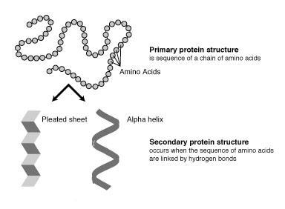
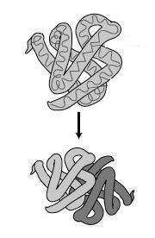
Primary protein structure is the sequence of a chain of amino acids
Tertiary protein structure occurs when certain attractions are present between alpha helices and pleated sheets

Amino acids

Pleated sheet
Alpha helix
Secondary protein structure occurs when the sequence of amino acids are linked by hydrogen bonds
Quaternary protein structure is a protein consisting of more than one amino acid chain

FIGURE 6-3

Lipids are molecules composed predominantly of just carbon and hydrogen and are important structural and energy storage compounds in the bodies of living things. Unlike the other macromolecule classes and unlike water, lipids are non-polar and therefore insoluble in water. Important lipid classes include; fatty acids, phospholipids, steroids, and waxes. Fatty acids are chains of carbon with a carboxyl group at one end. Fatty acids vary in their length and in the number of double bonds between carbon atoms in the chain. Fatty acids with only single bonds are said to be saturated (saturated with hydrogen). Alternatively fatty acids with double bonds between some of the carbons are said to be ‘unsaturated’. (A single double bond between two carbon atoms in the chain would be monounsaturated – multiple double bonds between carbon atoms along the chain would be ‘polyunsaturated’.)

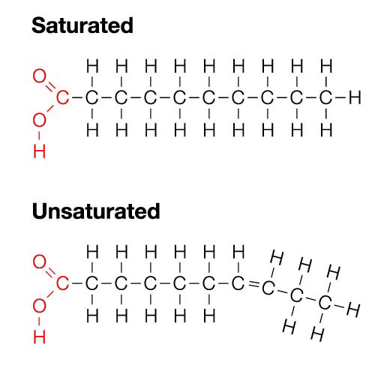

FIGURE 6-4

Saturated fatty acids are common in animals, are typically solid at room temperature, and in general are less healthy in your diet than unsaturated fatty acids – think of bacon fat. Unsaturated fatty acids are liquid at room temperature (often called oils), generally come from plants, and are healthier in your diet – think of olive oil. (Sometimes unsaturated fatty acids are purposefully saturated by bubbling hydrogen gas through them to make them behave more like naturally saturated fats – think of vegetable shortening like Crisco.)

Phospholipids make up the fabric of all biological membranes including those of the cell and nuclear membranes, the endoplasmic reticulum, the vesicles, the Golgi apparatus, lysosomes, and vacuoles. Phospholipids have polar hydrophilic (water-loving) regions and non-polar hydrophobic (water-fearing) regions that allow them to organize in bilayers. We will explore the nature of membranes in the osmosis lab. Steroids, like cholesterol, have a molecular structure that includes carbon rings. Many, like estrogen and testosterone, are important hormones that regulate patterns of development and determine a host of biological traits.

Nucleic Acids fall into two general classes; deoxyribonucleic acid (DNA) and ribonucleic acid (RNA). These molecules are responsible for all storage, expression, and transmission of genetic information. In a simplistic sense, DNA tells how to make protein. Since the information encoded in DNA determines which proteins will be made, and proteins determine all of the characteristics of an organism, you can think of the DNA as a set of instructions that tell exactly how to make a particular living thing. Just as any two non-clonal individuals do not share the same proteins, every individual’s DNA is also unique. In the gel electrophoresis lab you will use this uniqueness of DNA to run what is commonly referred to as a “DNA Fingerprint” – not because it has anything to do with an actual fingerprint, but because it can be used like a fingerprint for positive identification of an individual.

Like other macromolecules, nucleic acids are polymers, in this case, made up of monomers called nucleotides. Each nucleotide has three parts; a phosphate group, a five carbon sugar, and a nitrogenous base. The phosphate group of one nucleotide is linked to the sugar of an adjacent nucleotide in a phosphoester bond. The nitrogenous base of each nucleotide in DNA can be one of four possible bases; adenine (A), thymine (T), cytosine (C), or guanine (G). These four letters form the “alphabet” of the genetic code and remarkably can code for almost an infinite number of possible proteins – an endless variety of biological forms. In the lecture, you will learn more about the details of how DNA and RNA code for proteins and how they are copied and passed on from cell to cell, from parents to offspring.

In this diagram you see a short segment of a DNA molecule. Each circle shows the limits of one nucleotide. You will notice that DNA is not really a single polymer but two different polymers joined together in weak hydrogen bonds between the nitrogenous bases. This ‘double’ polymer takes the form of a twisted ladder and is called a ‘Double Helix’. This structural aspect of DNA is important in its ability to replicate (copy itself). We will explore that in more detail when we cover cell division in the mitosis lab.

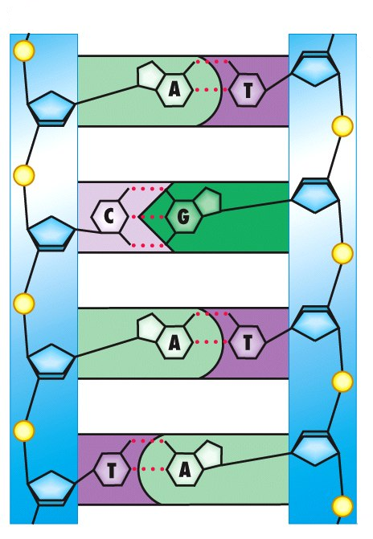

one nucleotide
phosphate group

phosphoester bond

deoxyribose sugar

nitrogenous base

FIGURE 6-5

In this lab you will explore different analytical tests that are used to detect the presence of specific macromolecule classes based on their properties. You will also have a chance to measure your own body mass index taking advantage of the bioelectrical impedance properties of body fat and an opportunity to extract your own DNA.

MATERIALS

Omron Fat Loss Monitor
bathroom scale
tape measure
water bath (hot plate and beaker)
Benedict’s solution
Biuret solution
Iodine Solution
10 samples for testing
10 test tubes
spot plates
brown paper squares
oil
15 ml tubes
water bath
ice cold ethanol
lysis buffer
meat tenderizer (protease)
small paper or plastic cup
water
eppendorf tube or small ‘genes in a bottle’ flask
straightened paper clip for spooling

Procedure

Testing for Carbohydrates and Proteins

There are two different tests you will use to detect the presence of carbohydrates in each of the samples provided. An iodine test is used to detect the presence of starch. CAUTION: Iodine is toxic and will permanently stain your clothing. Iodine intercalates into the helical structure of starch polymers resulting in a color change from yellow to bluish-black. In order to test each sample for the presence of starch, use the spot plates. Add 1 drop of the iodine solution to 15 drops of each sample. A positive result is a bluish-black color change. A negative result is typically a yellowish-brown color (the color of the iodine solution itself. Any color other than bluish-black is negative.

A Benedict’s test is used to detect the presence of a reducing sugar. The copper ion (Cu⁺²) contained within the Benedict’s reagent is reduced to Cu⁺ if it reacts with the free aldehyde or ketone group present in all monosaccharides and some disaccharides. In order for the reactions to take place, the reagents must be heated. For this reason you will have to perform the Benedict’s test in a test tube, and not the spot plate. Mix approximately equal volumes of each sample solution with the Benedict’s reagent. Then heat the test tubes in a water bath for 5 minutes. A positive test is noted by a color change to green, orange, brick red or brown. Green indicates a small amount of reducing sugar present, orange and brick red indicate increasingly larger amounts of the reducing sugar is present, and dark brown indicates the most reducing sugar present. A negative result is seen as blue (no color change).

A Biuret test is used to detect the presence of protein. Biuret reagent also contains copper ions (Cu⁺²) that form of a tetra-coordinated cupric ion with amino groups participating in a peptide bond. This complex is violet in color. A minimum of three amino acids must be covalently bonded via peptide bonds to react positively with biuret reagent. A Biuret test does not have to be heated, so you should conduct your tests for protein in the spot plates. Add 10 drops of each solution to be tested and 10 drops of Biuret reagent to each well. Mix with the end of a toothpick and look for a color change. A positive result will appear violet or rose-colored. A rose color indicates the presence of short chain polypeptides. A negative result will remain blue in color. Production of a yellow color indicates the presence of a strong acid that interferes with the accuracy of this test.

Sample | Prediction for Benedict’s Test | Results for Benedict’s Test | Prediction for Iodine Test | Results for Iodine Test | Prediction for Biuret Test | Results for Biuret Test
Glucose Solution
Bean Juice
Sucrose Solution
Saccharine Solution
Starch Solution
Albumin (egg white)
Milk
Regular Soda
Diet Soda
Grape Juice
TABLE 6-2

Clean your test tubes and spot plate after completing all of the tests.

Testing for Lipids and Estimating Body Mass Index

You can detect the presence of lipids using a small piece of brown paper. Lipids do not evaporate readily into air. They do, however, impregnate uncoated brown paper to form a translucent spot. Unlike aqueous solutions, the lipid residue will not readily disappear. You have undoubtedly noticed that the oil from greasy foods will adhere to a paper bag. Try this with four small pieces of brown paper. On one, place a drop of oil. On the others place a drop of milk, a drop of juice, and a drop of albumin respectively. Wait 30 minutes and then examine the four slips of brown paper. Describe the differences in the appearance of each spot. Does the milk, juice, or albumin appear to contain lipids?

You will now use bioelectrical impedance to estimate your own body mass index (BMI). Muscles, blood vessels, and bones have high water content so they conduct electricity well. Because body fat does not hold water it has low electrical conductivity. By passing a weak electric current through your body, you can estimate the percentage of your body mass that is made up of fat – more fat content, more bioelectrical impedance (less electrical conductivity).

This is an optional part of the lab. Hopefully at least one member of your group will be willing to estimate his or her BMI, but if you are uncomfortable doing this activity or you believe it may harm you, you should not measure your own BMI – use data from a classmate for your report.

You can actually calculate an approximate body mass index (BMI) using only your weight and your height. The purpose of this activity is to see whether or not using the Omron Fat Loss Monitor gives you a different estimate of body mass index than the simpler method. The imperial BMI formula uses weight measurements in pounds and height measurements in inches. Use the bathroom scale and the tape measure to estimate your height and weight then calculate your BMI using the imperial BMI formula and enter each value in the table.

(weight in pounds X 703 )
BMI =
height in inches²
Weight (pounds) | Height (inches) | BMI
 |  | TABLE 6-3

The table presented here indicates what are considered low, normal, high, and very high BMIs for adults. Notice that these BMI values vary some with age and gender.
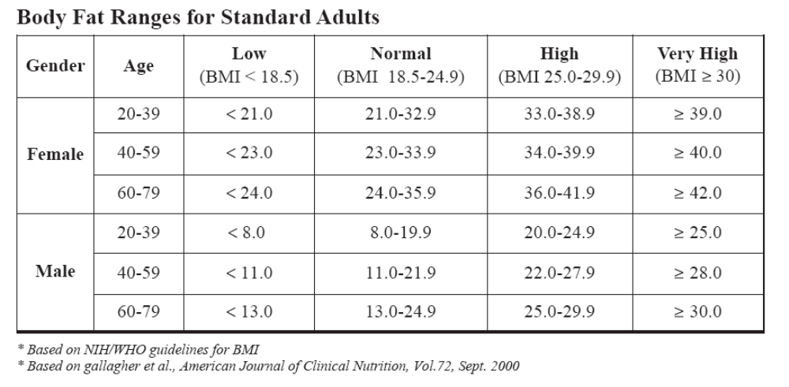

TABLE 6-4
Next, you will estimate your BMI using the Omron Fat Loss Monitor.

CAUTIONS for using the Omron Fat Loss Monitor:

The monitor cannot be used with a pacemaker or other implanted devices. Use of the monitor by a person with an implanted medical device could cause serious injury or death.

The monitor cannot be used by pregnant women or women who might be pregnant.

Hydrodensitometry, or underwater weighing, has been the established method for accurate evaluation of body composition. Omron has taken research information from several hundred people using the underwater method to develop the formula by which the Fat Loss Monitor works. The body fat mass and body fat percent are calculated by a formula that includes five factors: electric resistance, height, weight, age, and gender.

1. Press the On/Off button. All display symbols appear for approximately one second. The display symbols disappear and the GUEST symbol starts to flash.

2. Press the Set button for the GUEST mode. The NORMAL symbol flashes on the display. Press the Set button.

3. Set the HEIGHT between 3'4'' and 6'6''. Press the Up button or Down button to change the height. The value changes in increments of 1/4''. Press and hold the button to advance at a higher speed. Press the Set button.

4. The WEIGHT icon is indicated. The default value 135 lb flashes on the display. Set the weight between 23 lbs and 440 1/2 lbs. Press the Up button or Down button to change the weight. The value changes in increments of 1/2 lb. Press and hold the button to advance at a higher speed. Press the Set button.

5. The AGE icon is indicated. The default value 40 flashes on the display. Set the age between 10 and 80. Press the Up button or Down button to change the age. The value changes in increments of 1 year. Press and hold the button to advance at a higher speed. Press the Set button.

6. The default value MALE flashes on the display. Press the Up button or Down button to select MALE OR FEMALE. Press the Set button. All personal data is set. The indicator displays on the screen.

7. Stand with both feet slightly apart.

8. Place both hands on the monitor by holding the grip electrodes. Wrap your middle finger around the groove of the handle. Place the palm of your hand on the top and the bottom electrodes. Put your thumbs up, resting on the top of the monitor as illustrated.

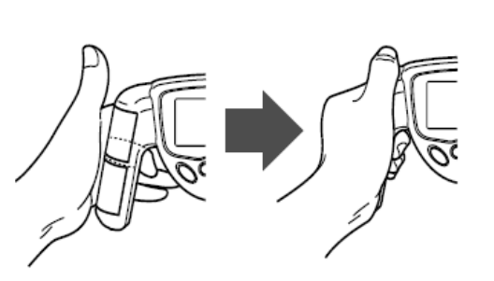

FIGURE 6-6

NOTE: The electric resistance may not be measured correctly in the following cases:
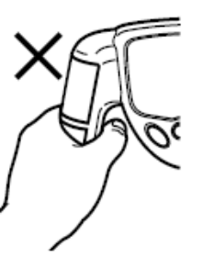
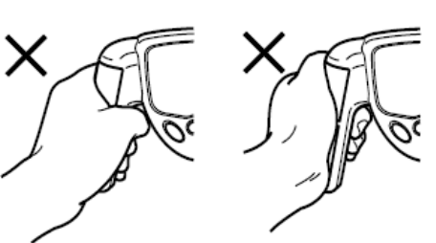

Your fingers are apart from the grips. Your hands are unevenly positioned toward the top or bottom of the electrodes.
FIGURE 6-7

HOW TO TAKE A MEASUREMENT
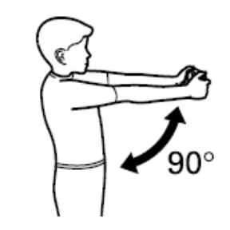
9. Hold your arms straight out at a 90° angle to your body. NOTE: Do not move during the measurement.

FIGURE 6-8

Measurement taken in the following positions may not provide accurate results:
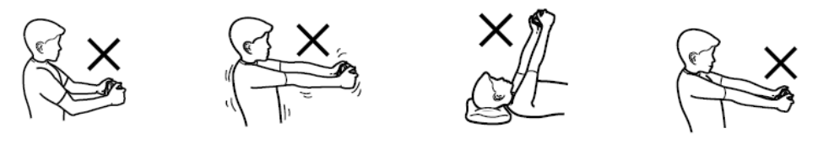

FIGURE 6-9
10. Press the Start button. The indicator appears on the screen.

11. Hold the electrodes with both hands. The monitor automatically starts the measurement. The BMI classification bar appears on the screen. The BMI classification, body fat percentage, and BMI are displayed. NOTE: Display value range: Body fat percentages - 4.0 to 50% BMI - 7.0 - 90.0 Record your values for comparison to the BMI calculated using the imperial BMI formula.
Extracting DNA from Cheek Cells

In this last part of the lab, you will have the chance to extract some of your own DNA and take it home with you. To extract your DNA, you will collect epithelial cheek cells, break them open and condense the DNA. You can collect thousands of cells from the inside of your mouth easily. The cells that line your mouth divide once or twice a day. Old cells fall off continuously and are replaced by new cells. Like sugar or salt, DNA is colorless when dissolved in liquid, but is white when it precipitates in large enough quantities to see it. As it precipitates, it appears as very fine white strands suspended in liquid. The strands are fragile, but they will clump together much like cooked noodles when pulled out of the liquid.

You will start by collecting cells from the inside of your cheeks using a simple rinsing procedure and then adding them to lysis buffer. The lysis buffer contains a detergent that breaks apart the phospholipid cell and nuclear membranes allowing the DNA to come out into solution. The lysis buffer also maintains the pH of the solution so that the DNA remains stable. You will add a protease (meat tenderizer) and incubate the cheek cell solution at 50°C.The protease enzyme digests proteins and will remove proteins bound to the DNA. DNA and other cellular components, such as fats, sugars, and proteins, dissolve in the lysis buffer. DNA has a negative electrical charge due to the phosphate groups on the DNA backbone, and the electrical charge makes it soluble. When salt is added to the sample, the positively charged sodium ions of the salt are attracted to the negative charges of the DNA neutralizing the electrical charge of the DNA. This allows the DNA molecules to come together instead of repelling each other. The addition of cold alcohol precipitates the DNA since it is insoluble in high salt and alcohol. The DNA precipitate will start to form visibly as fine white strands at the alcohol layer boundary while other cellular substances will remain in solution.

1. Obtain an empty 15 ml tube and a small cup with 3 ml of bottled water.

2. Make sure that your mouth is not full of food particles (i.e. do not eat right before doing this activity). Gently chew the inside of your cheeks for 30 seconds. Do not draw blood or injure the inside of your cheek!

3. Swish the 3 ml of water around in your mouth for 30 seconds and expel the liquid into the 15 ml tube. Add enough lysis buffer to the tube so that the tube is approximately half full. You need to leave room in the tube to add alcohol in step 8.

4. Place the cap on the tube and gently invert the tube 5 times (do not shake the tube).

5. Add a small amount (just what fits on the tip of a metal spatula) of the protease (meat tenderizer) to your tube. Place the cap on the tube and invert it a few more times.

6. Place the tube in the test tube rack in the 50° C water bath for 10 minutes.
7. Remove the tubes from the water bath. Obtain a bottle of ice cold ethanol from the freezer. (The alcohol must be ICE COLD. Take it out of the freezer right before you use it, work quickly, and put it back in the freezer as soon as you are finished so that it will be ice cold for the next group.)

8. Holding your 15 ml tube at a 45°angle, add ice cold alcohol to the tube. The cold alcohol should sit on top of the lysis buffer solution – do not let the two layers mix.

9. Place the cap on the tube and let it sit undisturbed for five minutes. After 5 minutes, gently invert the tube to help the precipitating DNA aggregate.

10. With a disposable plastic pipette, carefully transfer the precipitated DNA with some of the alcohol solution to a small glass vial to make a necklace. Alternatively, transfer the DNA to a small eppendorf tube so that you can take it home. Write down any observations that you made while doing the extraction.

Discussion Questions

1. Based on what you know about living organisms, would you expect many food substances to contain nucleic acids? Why or why not?
2. For your tests with the Benedict’s reagent, the iodine, and the Biuret’s reagent, were your predictions generally supported by your results? Were there any results that were particularly surprising? Do you have any new hypotheses to explain your unexpected results?
3. Was there a difference in BMI calculated with just weight and height versus the one calculated using the Omron Fat Loss Monitor? Can you explain any observed difference? Which method do you think is most accurate? Why?
4. Why do you think that the categorization of BMI as low, normal, high, and very high is dependent on age and gender? Why might your ideal BMI be different based on your age or your gender?
5. The lysis buffer contains detergents that break down cell and nuclear membranes? Why do you think detergent is used? (Think about the macromolecules that make up cell membranes.) Why do you think you heated the lysis buffer mixture in the water bath?
6. Water is a poor conductor of electricity, yet the water-filled parts of your body do not exhibit bioelectrical impedance like the fatty parts of your body. Why not?

